**Module 1 Activity 2: Project Setup**

Mohiddeen Vilak Mohammad

Department of Information Technology, Arizona State University

IFT 554: Middleware Programming & Database Security

Dinesh Sthapit

January 21, 2023

**Figure 1:**

*Screenshot of VS Code*

**Figure 2:**

*Screenshot of terminal*

**Figure 3:**

*Screenshot of running node on pc*

**Figure 4:**

*Screenshot of running npm on pc*

**Figure 5:**

*Screenshot of creating project*

**Figure 6:**

*Screenshot of creating ‘package.json’ file*

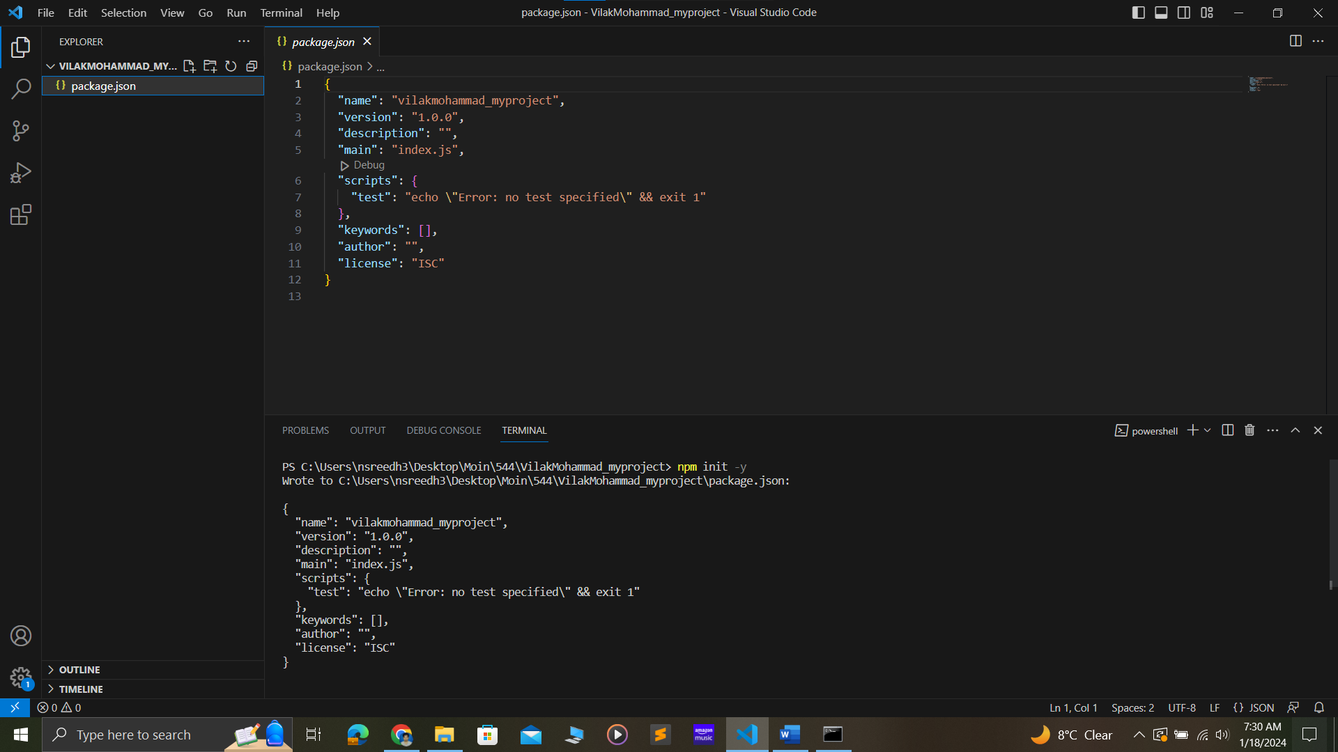

**Figure 7:**

*Screenshot of showing ‘index.js’ in file explorer*

**Figure 8:**

*Screenshot of showing ‘index.js’*

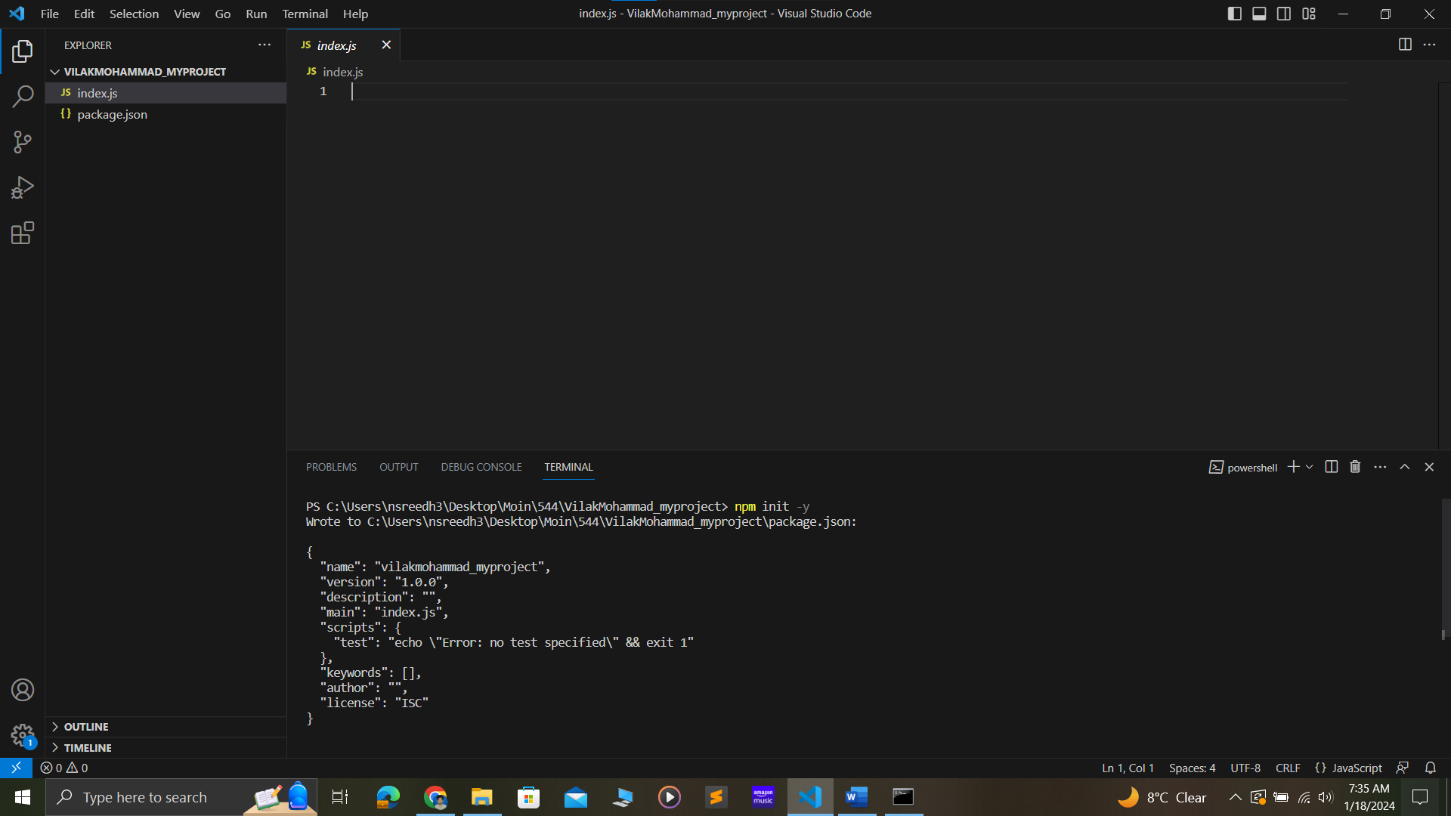

**Figure 9:**

*Screenshot of installing ‘express’*

**Figure 10:**

*Screenshot of code snippet*

**Figure 11:**

*Screenshot of ‘enabling autosave’*

**Figure 12:**

*Screenshot of running ‘index.js’*

